**Milestone Project 2 Read Me File**

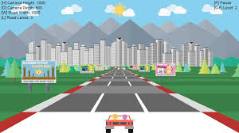

When starting this Milestone project, I decided to write a racing game, similar to the above picture. Upon attempting this, I was relying heavily on Phaser and decided that this was becoming too complex for what the project requires. There is a copy of the half written code in my GitHub repository. I then decided to build a basic version of the classic Atari game, Breakout, as this provides the demonstration of integration and usability required.

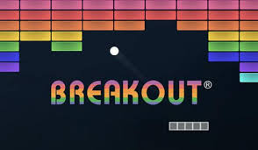

In my JS Validation check, I have 9 warnings remaining. These are due to only allowing this game to run on the up-to-date browsers.

I made the game easier to adjust for different screens by limiting the number of brick columns for the game.

I have used Google Gemini for some of the Javascript, to allow me to overcome some of the rendering and calculations, that I would usually use Phaser for, within my games.

Wireframe of the Page with the game.

I have only used the wireframe for a basic idea on layout that I would like and tried several layouts before finding one I was pleased with.

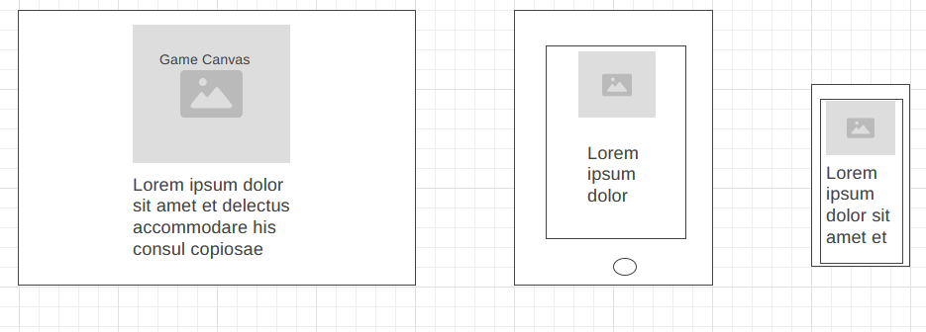

Colours, Headers and Canvas

Due to the game type, I think it will be best to leave the background of the canvas, as a solid colour. I will either use White or Black, depending on colours of bricks, paddle and ball. The Background of the webpage will either be a gradient type or an image. I have left 2 images in the folder, so if I were to develop the game further, each level would have a different background image.

|  |  |  |  |  |
| --- | --- | --- | --- | --- |
| **What for** | **Colour Name** | **Hex code** | **Web-safe colour** | **Swatch** |
| Text Colour (site presented) | LightBlue | **#add8e6** | **#99ccff** |  |
| Gradient background | Circled gradient | background: radial-gradient(circle,      rgba(0,17,36,0.9248291571753986) 26%, rgba(121,9,35,1) 49%, rgba(0,212,255,1) 74%) |  |  |
| Modal Text | Black | **#000000** | **#000000** |  |
| Brick colour 1 hit | Cyan | **#00ffff** | **#00ffff** |  |
| Brick colour 2 hit | Blue | **#0000ff** | **#0000ff** |  |
| Brick colour 3 hit | Red1 | #FF0000 | #FF0000 |  |

Background Image

I have chosen to tile the background image as I like the image, but it is too small for a large screen and if I stretch it, it will pixelate and look poor. Also with the tiling, the responsiveness of the image seems to work best. I also have a version of the gradient circle. Although I like this gradient, I feel that the background image suits better.Below are copies of backgrounds.

This seemed too busy.

I have added a filter to this image & decided that this image works best.

Testing

|  |  |  |  |  |
| --- | --- | --- | --- | --- |
| **Part of site** | **Use** | **How To Test** | **Result** | **Who performed?** |
| Responsive Screen | When site is used on different screen sizes ie tablet or phone | Use resize function to shrink and grow the screen | As expected, all responding to different sizes of screen | Rob |
| Input and Label  Start Game button | Add username for scoreboard.  Validation check to ensure name is entered before starting | Click Start game with no name inserted.  Click button with a name to make sure modal pops up and canvas loads. | All working as expected | Rob |
| Game |  |  |  |  |
| Paddle moving | Bounce ball to break bricks | Use arrow keys complete levels | Working well. | Rob |
| Ball moving as expected | Bouncing off walls paddle and dropping through the floor. | Play the game. | Working well. | Rob |
| Bricks working as expected | Break bricks to increase score | Play the game | Working well | Rob |
| Lives, game over, level up and win game | Modals, scoring and life counter | Play game to all conclusions | Working as expected. | Rob |
| Scoreboard update | On game over or win game, scoreboard updates with name & score. | Playing the game. | Working as needed. | Rob |
| Bricks breaking no. | 1 hit, 2 hit, 3 hit to break | When playing the game, check colour change on hit and breaks okay | Working as expected. | Rob |